Parts of a Tree
Part 1:
Directions: Label the parts of the tree below by filling in the blanks with the following terms:
- Bark
- Xylem
- Heartwood
- Cambium
- Phloem

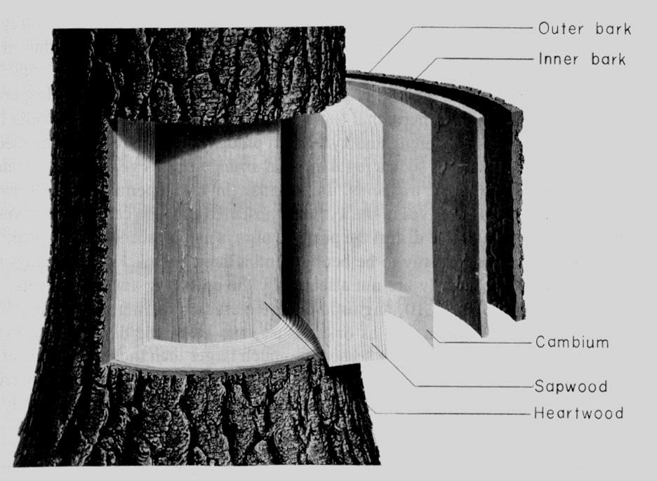

Part 2:
Let’s practice some more. This time we are looking at a tree from a different perspective.
Directions: Label each part of the tree that an arrow points to. Rise to the Challenge: No word bank!
