American Museum of Natural History
The Hall of New York State Environment & the NYC Watershed

The Felix M. Warburg Hall of New York State Environment focuses on the village of Pine Plains and Stissing Mountain in New York’s Dutchess County, an area that includes mountains, natural lakes, forests, rock formations, and both wild and cultivated land. The hall’s exhibits highlight the changes in the landscape since Precambrian times, its seasonal and natural cycles, and its plant and animal life.
Cutaway views of the mountain and terrain, along with fossils, mineral specimens, and topographical maps, illustrate the geologic history of the area. Another series of exhibits describes the role of agriculture on the local ecology, with displays about crop rotation, the management of an apple orchard, natural fertilizers in the soil, and the cycles of nutrition and decay. Dioramas also showcase forest and wetland ecosystems.
An exhibit about life in the soil depicts animals living below ground in a farmer’s lawn and at the edge of woodland, with views of tunnels, nests, and burrows used by moles, chipmunks, mice, yellowjackets, Japanese beetle larvae, ants, and earthworms.
Check out these WATERSHED points of interest:
- Agriculture and land use history
- Roots in the Soil
- Soils and Soil Conservation
- Topographic map of Southern New York State (big, vertical map around corner from Stissing Mountain Diorama)
- Diorama: October Morning near Stissing Mountain
- Topo Map/Diagram: Birds Eye View of Stissing Mt. and Village of Pine Plains

Student Activity & Lesson Ideas
Generated by teams of Watershed Forestry Educators at the Museum on Saturday, January 17, 2015

Guiding Questions:
- What evidence can a cross section of a tree give you about past weather conditions?
- What is the relationship between temperature and water density? How would that impact the aquatic organisms in different seasons?
- How would the geology and surface morphology impact the size and shape of the bodies of water bodies or watersheds?
- How would the type of soil impact the water quality in the watershed?
- Looking at the farming diorama, how might the different human activities impact the quality of water in the watershed?

Post-visit Activities:

- Watershed Engineers: Create a model of your “ideal” watershed (draw, sculpt, etc.) In your design, consider how you would make it ideal for:
  - Water quality
  - Biodiversity
  - Human populations (employment, health, recreation, etc.)
- Follow the Arrows: Take pictures of different exhibit displays and print them after your visit. Have students draw arrows on the pictures to show how water would move across the land.
  - What substances and objects will the flowing water run into?
  - What materials will the flowing water pick up and move?
  - Where will this material end up?
  - What impacts might this have on the quality of the environment?

Exhibit Photos and Focused Questions by Bob Ward:

Questions for “The Hillside Near a Pond”:
Many creatures live within a watershed. They all need clean water and a place to live.
Do you think the animals shown in this diorama will contribute o pollution in the nearby lake? Why or why not?
Do you think this animal's home will flood during heavy rain? Why or why not?
In this diorama is there any evidence that man has influenced or changed the natural environment?

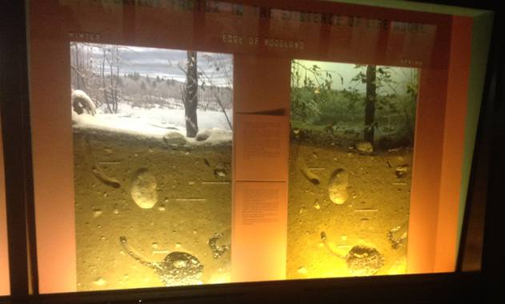

Questions for “Thompson's Pond Diorama”
A good definition of an aquatic macroinvertebrate is a small creature without a backbone that can be found on the bottom of a river or stream. Which creature shown in this diorama is an aquatic macroinvertebrate?___________________ What do you think this creature might eat?

Some insects in their adult stage can breathe air and fly, and in an earlier stage of their life they get oxygen from water and live as aquatic macroinvertebrates. Do you know which creature in this diorama meets this criteria? ___________________
Do you see any evidence in this diorama that humans have manipulated this natural setting?
If we define human pollution as things left in the environment that do not belong there, do you see anything in this diorama that you would call pollution?
If we define the top predator in an ecosystem as both (1) an animal that can eat smaller creatures and (2) an animal this is not preyed upon by another larger creature in the ecosystem, can you name a top predator in this diorama? __________________
